PAGE 1: Landing page home screen

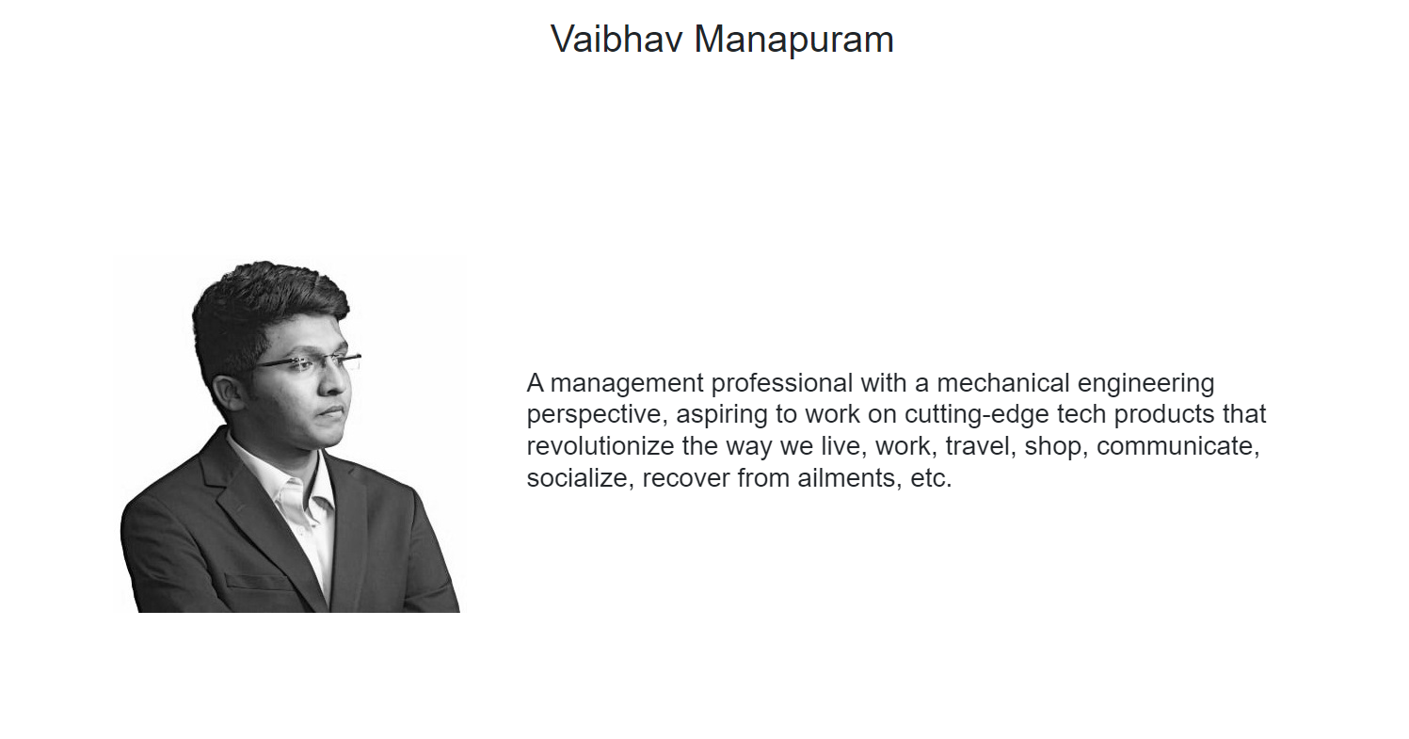

CHANGE: Replace photo with the new passport size front view pic (edited the height of the photo to get better fit)

PAGE 2: MEM @ Duke...

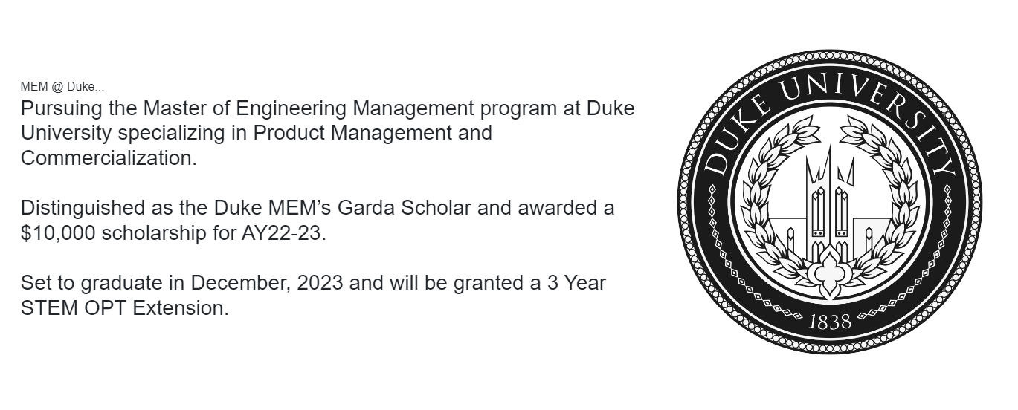

CHANGE: Retain same Duke logo image and replace the above text with:

MEM @ Duke...

Graduated with a Master of Engineering Management degree from Duke University specializing in Product Management and Digital Transformation.

Distinguished as the Duke MEM’s Garda Scholar for AY22-23 and awarded a scholarship.

Graduated in May, 2024 and granted with a 3 Year STEM OPT employment authorization.

PAGE 3: - ADD NEW PAGE - Leadership @ Duke...

**\* NEW PAGE \***

CHANGE: ADD THIS LOGO SHOWN BELOW and the text below that as well -

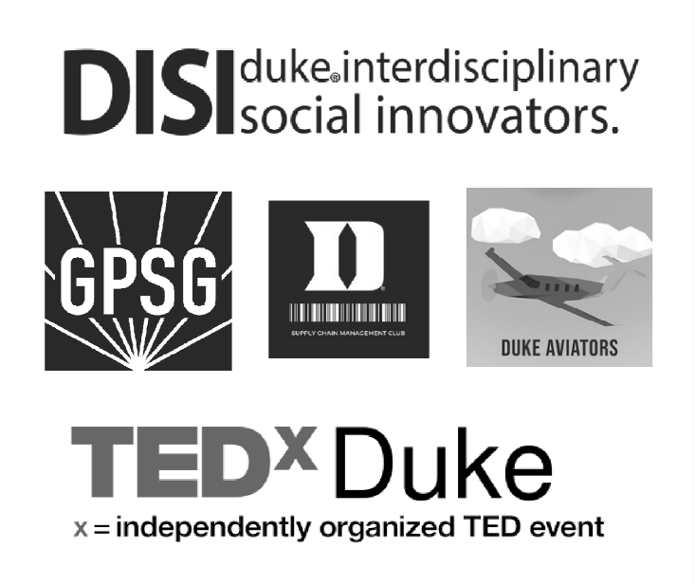

Leadership @ Duke...

Elected as the Senator for Graduate & Professional Student Government at Duke, served on the Graduate/Professional Young Trustee nomination committee, ensuring student representation at the highest level of university governance, and also served on the Climate Crisis Committee.

Served as the Executive Cabinet Member for the Supply Chain Management Club, and catalysed professional development and networking opportunities for Supply chain aspirants.

Served as the Executive Director of Project Operations at Duke Interdisciplinary Social Innovators (DISI), providing pro bono consulting services to social organizations in impact evaluation, capacity building, strategy, technology integration, finance and thus enabling positive change.

Served as the Vice President of the Duke Aviators Graduate Group, organized Discovery flights, installed Flight Simulators, and fostered a vibrant hub for aviation enthusiasts at Duke.

Served on the General Body Committee of TEDx Duke, curated a diverse line-up of speakers & created an engaging audience experience.

PAGE 4: Graduate life @ Duke...

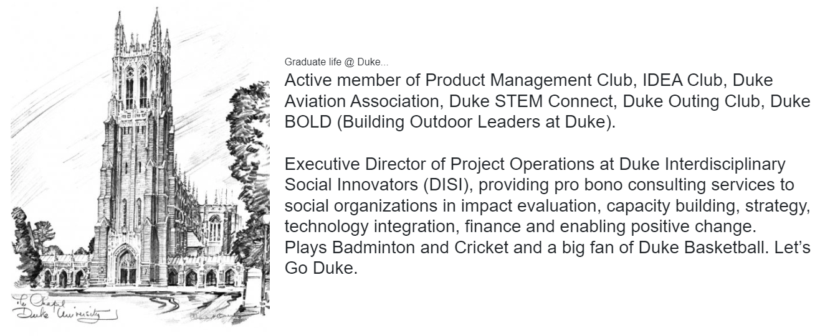

CHANGE: Retain same logo but replace text as below:  
  
Graduate life @ Duke...

Active member of Product Management Club, IDEA Club, Duke Aviation Association, SCM Club, Duke STEM Connect, Duke Outing Club, Duke BOLD (Building Outdoor Leaders at Duke).

Served as the Teaching Assistant for the 'Challenges to Design Thinking' course during AY 2023-24.

Served as the House Manager and Student Assistant for Duke Box Office and Duke Performances.

Played Badminton, Squash and Cricket and a big fan of Duke Basketball. Let’s Go Duke!

PAGE 5: ADD NEW PAGE - Entrepreneurial stint…

**\* NEW PAGE \***

CHANGE: ADD THE IMAGE BELOW AND ADD THE FOLLOWING TEXT AS WELL



Entrepreneurial stint…

Founded LittLearn, a company that develops next gen learning products and smart toys.

Developed a flagship product called Mosaic, which is a smart toy that fosters STEM learning in school students.

Achieved a 40% faster time-to-market for 'LittLearn' by effectively defining success criteria, OKRs, and KPIs, and streamlining feature prioritization.

Delivered high-quality product updates on time by leading comprehensive market analysis, competitive research, and agile project management throughout the product lifecycle.

PAGE 6: Notable milestones...

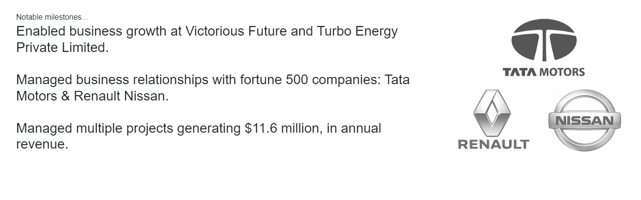

CHANGE: Replace both the image and text with the following



Notable Professional milestones...

Executed the design thinking-driven revamp of Adobe’s Confluence Wiki for the Technical Account Management division, thus boosted Knowledge transfer efficiencies by over 45%.

Enabled business growth at Victorious Future and Turbo Energy Private Limited.

Managed business relationships with fortune 500 companies: Tata Motors & Renault Nissan.

Managed multiple projects generating $11.6 million, in annual revenue.

PAGE XYZ_1: I love giving back...

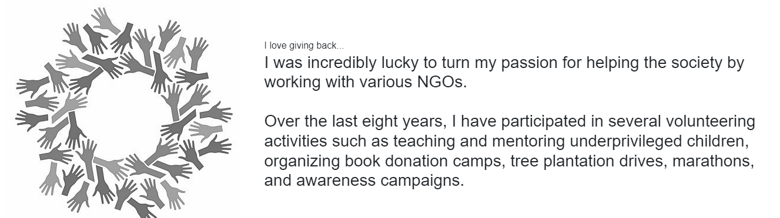

CHANGE: Replace the text with the following + RETAIN SAME IMAGE

I love giving back...

I was incredibly lucky to turn my passion for helping the society by working with various Non-profits.  
  
Over the last eight years, I have participated in several volunteering activities such as teaching and mentoring underprivileged children, organizing book donation camps, tree plantation drives, marathons, and awareness campaigns.

PAGE XYZ_2: Love to travel...

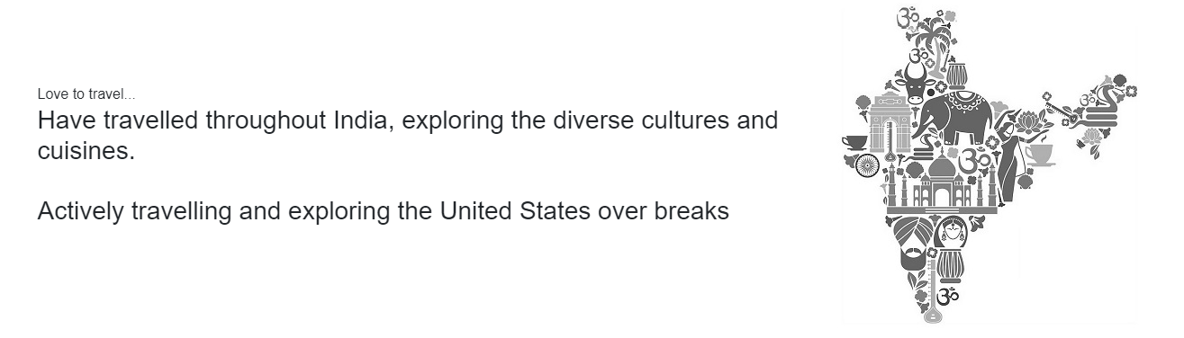

CHANGE: Replace both the image and text with the following

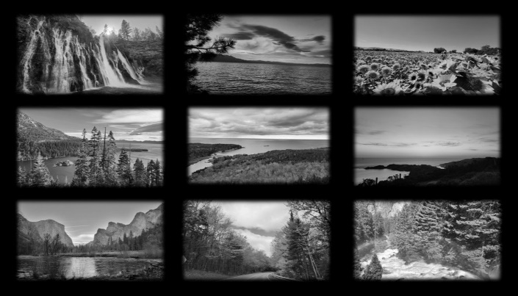

Love to travel...

Have travelled throughout India, exploring the diverse cultures and cuisines.  
  
Actively travelling and exploring the United States and its majestic National Parks.

PAGE XYZ_3: Last page

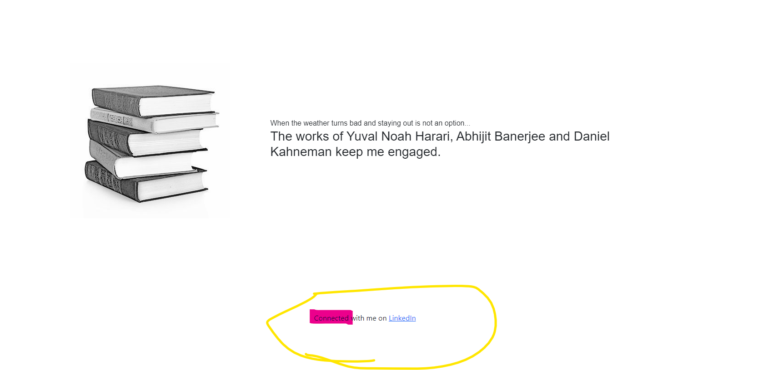

CHANGE 01: Replace the text with the following and retain the same pic

When the weather turns bad and staying out is not an option...

The works of Yuval Noah Harari, Don Norman, and Daniel Kahneman keep me engaged.

CHANGE 02: Replace the word “Connected” with “**Connect**”